**LECTURE 1**

**Introduction and History of Artificial Intelligent(AI)**

Since the invention of computers or machines, their capability to perform various tasks went on growing exponentially.

Humans have developed the power of computer systems in terms of their diverse working domains, their increasing speed, and reducing size with respect to time.

A branch of Computer Science named Artificial Intelligence pursues creating computers or machines as intelligent as human beings.

**What is Artificial Intelligence?**

According to the father of Artificial Intelligence, John McCarthy, it is The science and engineering of making intelligent machines, especially intelligent computer programs.

Artificial Intelligence is a way of making a computer, a computer-controlled robot, or a software think intelligently, in a similar manner the intelligent humans think.

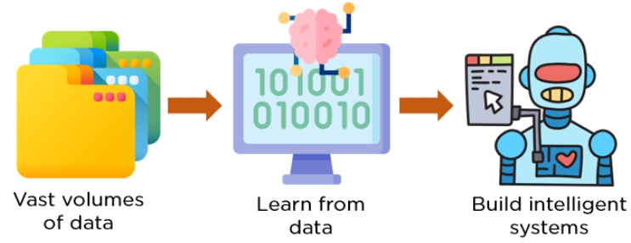

AI is now being used in almost every sector of business:

* Transportation
* Healthcare
* Banking
* Retail
* Entertainment
* E-Commerce

Now that you know what AI really is, let’s look at the different types of artificial intelligence.

**What is Intelligence in Artificial Intelligent - AI**

A system that is responsive to humans, often relying on artificial intelligence. **For example** a computer that standbys your computer when you leave your office or look away and logs you back in when you do.

**What is Intelligence in Artificial Intelligent (AI)**

**Definition of intelligence in the Context of Artificial Intelligent (AI):** Understanding the ability, calculation, reason, relationships and analogies of a system, learning from experience, learning from the store and memory, solving problems, understanding complex ideas, using natural language, the ability to use fluently, classify, generalize, and adapt new situations. **Artificial intelligence** is where people are tired of natural intelligence and want machines to tell them what they want to hear. Like preferring synthetic orange juice as a sweeter option compared to the naturally sweet orange juice.

**Definition of Intelligence** with the scope of AI keeping in mind, is defined as:

**1.) Ability to take decisions:**

The ability to make complex decisions from a set of factors that make a large number of decision-makers. Making the optimum, accurate and accurate decision is very important. It measures your intelligence in general terms as well as in the context of AI.

**2.) Ability to prove results:**

Once you make a decision, then the ability to prove that the decision has been chosen, it matters a lot, and in this way this factor also measures the intellect.

**3.) Ability to think logically:**

There are many things in the world, which can't be proven by a mathematical formulae or proof, instead you apply your common sense, think logically and come to a conclusion. This ability to think logically and apply common sense also measures intellect.

**4.) Ability to learn and improve:**

Every time we learn something new, we develop our experiences and these experiences help us in making better decisions and better opportunities in the future. In the context of AI and generic, it is similar in the case of intelligence.

The more you learn from the external environment, you should have the ability to get some new information every time. Therefore, the factors above mentioned will get your wisdom criteria.

Apart from this, research and work is going on in the field of AI, in which they are trying to increase the intelligence of machines and systems which can be better decision, give better reasoning, think more logically and learn from the environment.

An AI system is composed of an agent and its environment. The agents act in their environment. The environment may contain other agents.

**LECTURE 2**

**What is agent?**

An **agent**is anything that can perceive its **environment**through **sensors**and acts upon that environment through **actuators.**

* A **human agent**has sensory organs such as eyes, ears, nose, tongue and skin parallel to the sensors, and other organs such as hands, legs, mouth, for effectors.
* A **robotic agent**replaces cameras and infrared range finders for the sensors, and various motors and actuators for effectors.
* A **software**agent has encoded bit strings as its programs and actions.

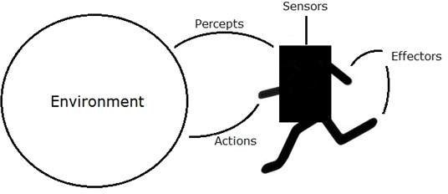

**Agent Terminology**

* **Performance Measure of Agent**− It is the criteria, which determines how successful an agent
* **Behavior of Agent**− It is the action that agent performs after any given sequence of
* **Percept**− It is agent’s perceptual inputs at a given
* **Percept Sequence**− It is the history of all that an agent has perceived till
* **Agent Function**− It is a map from the precept sequence to an agent.

**There are the Importance of Artificial Intelligence**

**1. Game Playing**

You can buy machines that can play master level chess for a few hundred dollars. There is some AI in them, but they play well against people mainly through brute force computation--looking at hundreds of thousands of positions.

To beat a world champion by brute force and known reliable heuristics requires being able to look at 200 million positions per second.

**2. Speech Recognition**

In the 1990s, computer speech recognition reached a practical level for limited purposes. Thus United Airlines has replaced its keyboard tree for flight information by a system using speech recognition of flight numbers and city names.

It is quite convenient. On the other hand, while it is possible to instruct some computers using speech, most users have gone back to the keyboard and the mouse as still more convenient.

**3. Understanding Natural Language**

Just getting a sequence of words into a computer is not enough. Parsing sentences is not enough either. The computer has to be provided with an understanding of the domain the text is about, and this is presently possible only for very limited domains.

**4. Computer Vision**

The world is composed of three-dimensional objects, but the inputs to the human eye and computers' TV cameras are two dimensional. Some useful programs can work solely in two dimensions, but full computer vision requires partial three-dimensional information that is not just a set of two-dimensional views.

At present there are only limited ways of representing three-dimensional information directly, and they are not as good as what humans evidently use.

**5. Expert Systems**

A ``knowledge engineer'' interviews experts in a certain domain and tries to embody their knowledge in a computer program for carrying out some task. How well this works depends on whether the intellectual mechanisms required for the task are within the present state of AI. When this turned out not to be so, there were many disappointing results.

One of the first expert systems was MYCIN in 1974, which diagnosed bacterial infections of the blood and suggested treatments. It did better than medical students or practicing doctors, provided its limitations were observed. Namely, its ontology included bacteria, symptoms, and treatments and did not include patients, doctors, hospitals, death, recovery, and events occurring in time.

Its interactions depended on a single patient being considered. Since the experts consulted by the knowledge engineers knew about patients, doctors, death, recovery, etc., it is clear that the knowledge engineers forced what the experts told them into a predetermined framework. The usefulness of current expert systems depends on their users having common sense.

**6. Heuristic Classification**

One of the most feasible kinds of expert system given the present knowledge of AI is to put some information in one of a fixed set of categories using several sources of information.

An example is advising whether to accept a proposed credit card purchase. Information is available about the owner of the credit card, his record of payment and also about the item he is buying and about the establishment from which he is buying it (e.g., about whether there have been previous credit card frauds at this establishment).